Shivin Devgon and David Feng

EE16B Spring 2018

Profs. Roychowdhury and Maharbiz

**SIXT33N Project Report**

**Front End Circuit**

The front end circuit consisted of four main parts: the mic board, OS1: DC Offset, OS2: Level Shift and a band-pass filter.

1. Mic board: The mic on the mic board behaved like a variable current source and we used the Mic Gain part of the circuit to turn it into a voltage signal. Then we applied DC Offset on the voltage signal and used an non-inverting amplifier to amplify the microphone signal.
2. OS1: DC Offset: We needed to center our signal around the center of our voltage range(0 -3.3v) so we set the DC Offset to be 1.65v. If we did not apply DC Offset, we would lose the negative part of our signal because we did not have a negative voltage source. Therefore, we used a voltage divider of two 10k𝛀 resistors from 3.3v to 0v.
3. OS2: Level Shift: We set the reference of the non-inverting amplifier to be the same as our DC Offset(1.65v) so that the DC Offset would not be amplified. Since the resistors could vary up to 5%, we used potentiometer to help us make two resistors match so that the Level shift was 3.3/2 = 1.65v
4. Band-pass filter: Since the frequency range for the human’s most speech was about most speech falls between 250 Hz and 2500 Hz, we built the bandpass filter by choosing the resistors for low-pass filter and high-pass filter to be 6.2k𝛀, the capacitor for low-pass filter to be 0.01𝝁F and the capacitor for high-pass filter to be 0.1𝝁F
5. Decoupling capacitor: A decoupling capacitor was used to introduce more noise from power rails
6. Voltage regulator: Since the battery was 9v. We used voltage regulator LM7805 to reduce the voltage to 5v as the power source for the front end circuit.

**Front End Circuit Schematic**

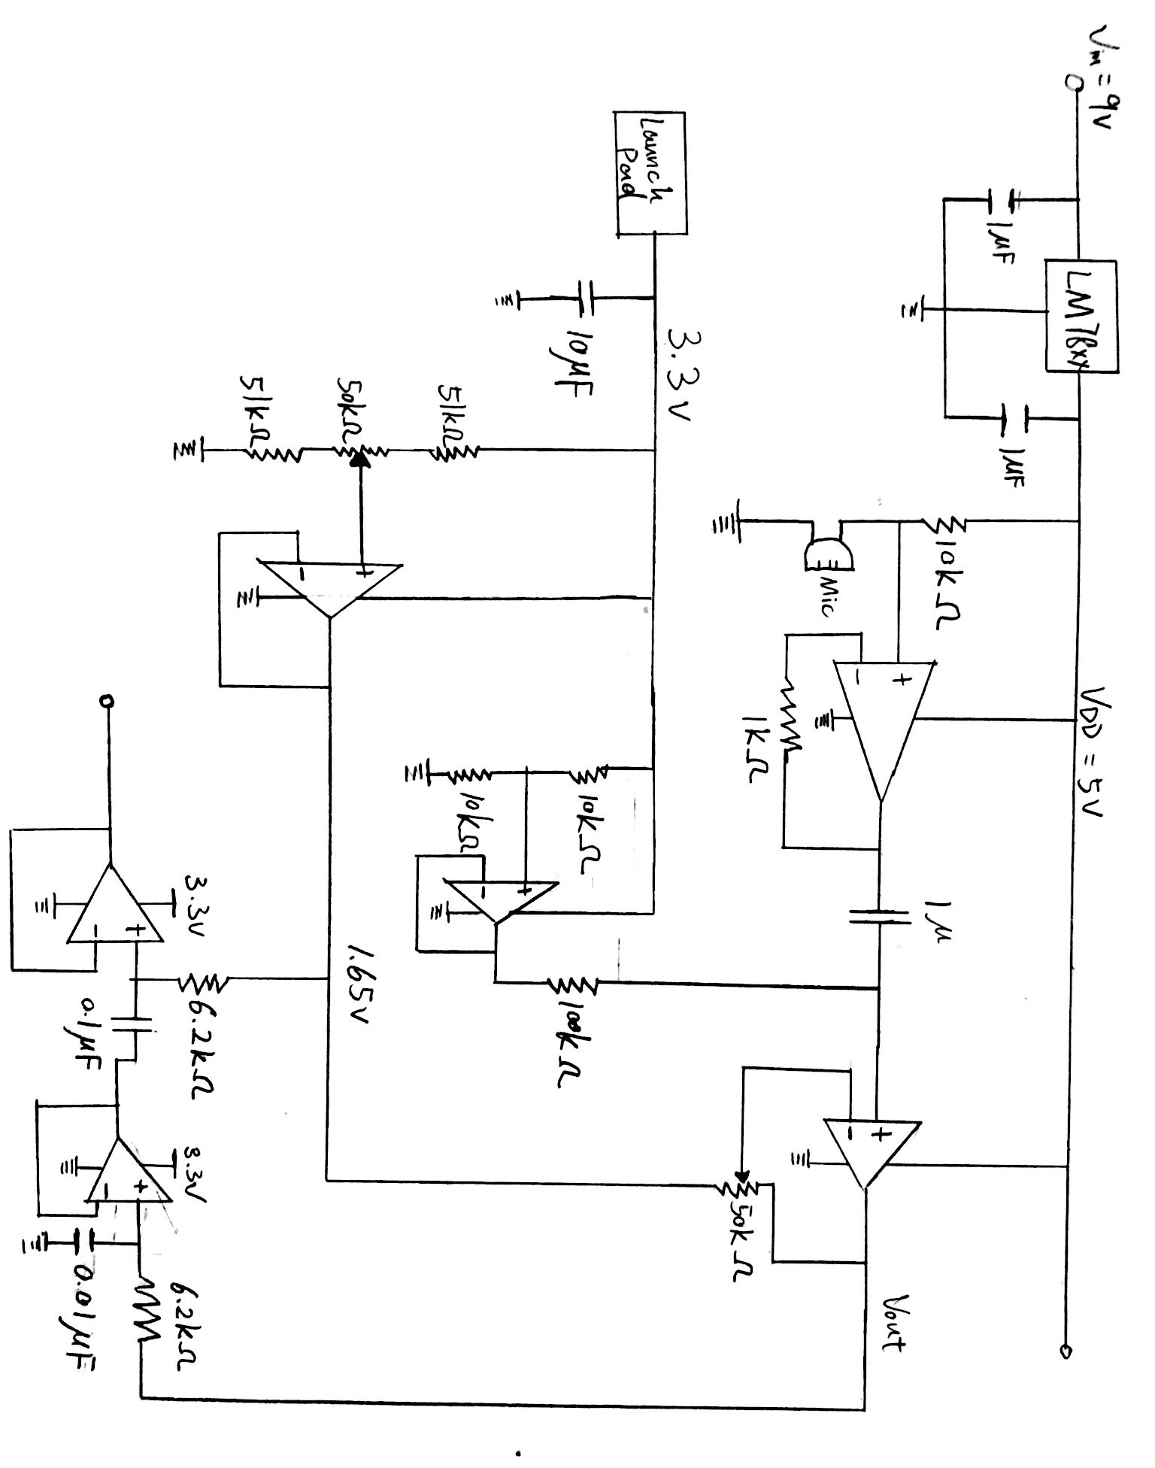

**PCA**

We tried the words Trump, Elephant, Negative, Feedback, Illuminati, Feedback, and Technology. After trial and error, we found out that Trump, Feedback, Technology, and Illuminati worked the best and were easily distinguishable from each other. For “Feedback,” I extended the length of the first syllable and for “Technology” I said it slower than I said “Illuminati.” This made our accuracy almost 100% and the voice recognition was perfect during testing and in the live demo.

**Controls - Open Loop**

Our model had $θ_{left}$ = 0.2658, $θ_{right}$ = 0.2989, $β_{left}$ =-25.08, $β_{right}$ =-14.11, and v* = 78.1 as the parameters for a linearized system. The open loop model was

$u_{left}[t]=\frac{{v^{*}+β}_{left}}{θ_{left}}$ and $u_{right}[t]=\frac{{v^{*}+β}_{right}}{θ_{right}}$

$u_{left}$ and $u_{right}$ are the inputs, and they have a range from 170 to 240 because that is the range in which the relationship between velocity and input is linear. The open loop model did not work very well, particularly because the $θ$ and $β$ values were not accurate and there was a model mismatch, which continuously exacerbated the error.

**Controls - Closed Loop**

Closed loop feedback is necessary because it corrects the error term $δ[t]=d_{left}[t]-d_{right}[t]$ and prevents it from increasing over time. With closed loop feedback, the system accounts for the error term, and lowers the input power of the wheel which has traveled farther than the other. This causes the wheels to travel the same distance, which is equivalent to moving straight. The closed loop model kept the same values for $θ$ and $β$, but added an additional component to the input value. Specifically, the inputs became

$u_{left}[t]=\frac{{v^{*}+β}_{left}}{θ_{left}}-k_{left}\frac{δ[t]}{θ_{left}}$ and $u_{right}[t]=\frac{{v^{*}+β}_{right}}{θ_{right}}+k_{right}\frac{δ[t]}{θ_{rightt}}$

We needed the k values to be less than 1 so that the eigenvalue of the error term was between -1 and 1, causing the error term to converge to 0 with a perfect model or a constant term $δ_{ss}$ with model mismatch. We chose the k values of $k_{left}=0.8$ and $k_{right}=0.9$ because it gave a low value for $δ_{ss}$ and had less initial error. With these large eigenvalues, there are oscillations in the beginning, but the car ran straight.

**Controls - Turning**

Previously we used $δ[t]$ for analyzing how the car deviated from moving straight. We can use this error term to define a turn for the car too. If $δ[t]$ is positive, then the left wheel has moved more than the right wheel and it is a right turn. If $δ[t]$ is negative, then the right wheel has moved more than the left wheel and it is a left turn. We keep the same closed loop model, but change the error term so that

$δ[k]=\frac{v^{*}lk}{5r}$, where l is the length of the car and r is the turning radius. The 5 comes from the differences in sampling period of the closed loop equation and the data collection.

Then, when plugging in $δ[t$] into the closed loop equation, we would subtract $δ[k]$ from the initial value because a negative $δ[t$] results in a right turn and vice versa.

**Closed Loop Feedback Block Diagram**

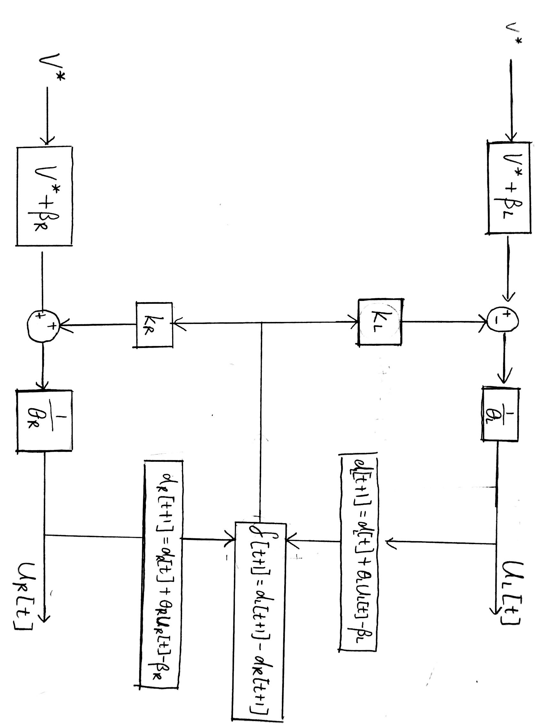

**General**

The most important thing we learned from this project was process of how we completed every individual parts one by one and integrated them to become a toy car that can be controlled by our voice and the process of how we built the actual circuit from the scratch. The step-by-step process helped us to improve our circuit debugging skills and circuit creation skills. We colored coded wires and probed all input points, which allowed us to isolate the possible sources of error and fix it. We also learned how to apply the knowledge learned from the EE16B lecture to a real EE project. Doing this lab helped improve our understanding of PCA, SVD, and closed loop feedback because we applied it to a real life object rather than crunching numbers on paper.